**Part 3 – Database Driven Website**

Our clients pride themselves on their ability to add last minute adventures. It is important to them to have the ability to add adventures quickly and from their phones. They would like to see how a site administrator would go about adding an Adventure.

admin-add.php admin-confirm.php all-adventures.php

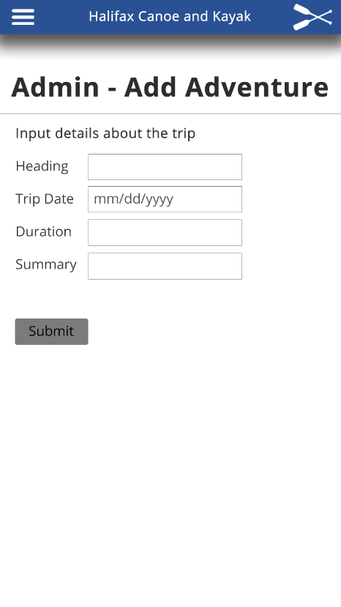

**Pro Tip: Use Part 1 and 2 style as a starting spot**

Requirements:

* A database with 5 fields (id and the 4 fields below)
* Within admin-add.php
* Make a form with the following fields:

1) heading, 2) tripDate, 3) duration, 4) summary

* admin-confirm.php must add the data entered from the from into the database
* admin-confirm.php must confirm data has been entered and have a link to all-adventures.php
* all-adventures.php must list all entries in the database and display them in a manner similar to above

**Detailed Instructions**

Using phpMyAdmin create a database with a table. It should have 5 columns

Column 1: id -> Int, Unique, and auto incrementing

Column 2: heading -> varchar with a limit on the characters

Column 3: tripDate -> Date

Column 4: duration -> Int, length 3

Column 5: summary -> text

Each php page must connect to the database - I suggest using includes

**Supplied Assets:**

* The main image:

<https://raw.githubusercontent.com/Zulinov/skillsProjects/main/canoe.jpg>

* Hamburger icon: <https://raw.githubusercontent.com/Zulinov/skillsProjects/main/hamburger.png>

**Submitting Instructions:**

1. Upload your complete project (html file, css file(s), images, etc.) to GitHub.

* Be sure to include your first name and last name.

1. Create an account,
2. Post ...